8.1 Enthalpy change
Name: ____________________ Class: ____________________ Due date: 12.15
1. The diagrams show the difference in energies of the reactants and products in two types of reaction. 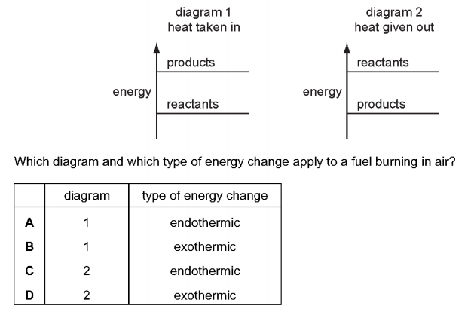
Which diagram and which type of energy change apply to a fuel burning in air?（ ）
2. The diagram shows a match
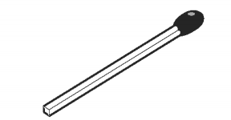
By striking the match, a chemical reaction takes place.
Which statements about the chemical reaction are correct? （ ）
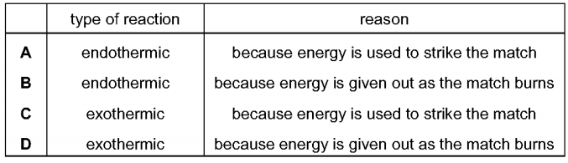

3. Some reactions are endothermic
How does the temperature and energy change in an endothermic reaction? （ ）
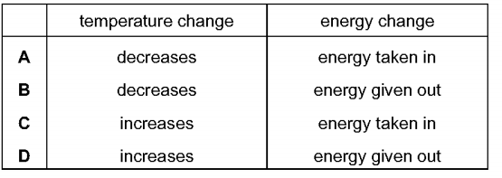

4. When ammonium nitrate is added to water the temperature of the water decreases. The ammonium nitrate can be recovered by evaporating the water added.
Which explains these observations? （ ）
A The ammonium nitrate dissolves in the water and the process is endothermic.
B The ammonium nitrate reacts with the water and the process is endothermic.
C The ammonium nitrate dissolves in the water and the process is exothermic.
D The ammonium nitrate reacts with the water and the process is exothermic.
5. Solutions of two chemicals are mixed.
A reaction occurs and the temperature change is measured.
Which statement is correct? （ ）
A If the reaction is endothermic, the temperature decreases and energy is taken in.
B If the reaction is endothermic, the temperature increases and energy is given out.
C If the reaction is exothermic, the temperature decreases and energy is given out.
D If the reaction is exothermic, the temperature increases and energy is taken in.

6. When anhydrous copper(ll) sulfate is added to water a solution is formed and heat is given out.
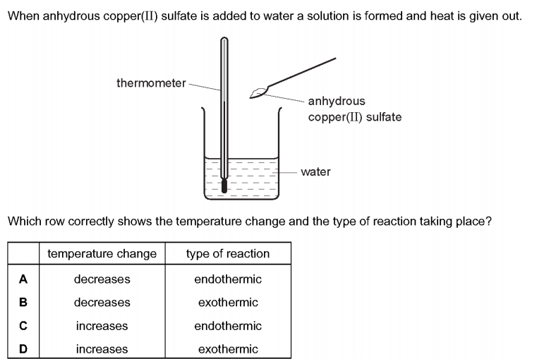
Which row correctly shows the temperature change and the type of reaction taking place? （ ）

7. Which statements about exothermic and endothermic reactions are correct? （ ）
1 During an exothermic reaction, heat is given out.
2 The temperature of an endothermic reaction goes up because heat is taken in.
3 Burning methane in the air is an exothermic reaction.
A 1, 2 and 3 B 1 and 2 only C 1 and 3 only D 2 and 3 only

9. Which experiment is the most exothermic? （ ）
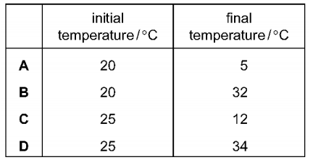
10. Some properties of four fuels are shown in the table.
Which fuel is a gas at room temperature and makes two products when it burns in a plentiful supply of air? （ ）
